Week 33
Capstone Project: Smart City Traffic Intelligence: From Data Analytics to AI-Powered Mobility

Part 1 – Data Analytics: Understanding Traffic Patterns
Learning Outcomes Addressed:
- Use SQL to analyse real-world datasets and identify meaningful trends, patterns and changes over time or across relevant categories.
- Apply descriptive statistics and correlation analysis to summarise data and examine relationships between variables.
- Apply probability and conditional probability concepts to assess the likelihood of events and relationships between relevant variables.
- Transform, clean and prepare data using Power Query to support effective analysis and visualisation.
- Develop interactive Power BI dashboards that communicate key findings and data-driven insights clearly to non-technical stakeholders.
- Interpret analytical results and translate them into actionable, evidence-based insights to support decision-making in a real-world context.

Tasks
Task 1: SQL-Based Traffic Analysis
Using the Metro Interstate Traffic Volume dataset:
1.1 Load the dataset
- Load the comma-delimited traffic CSV file into SQLite.
- Verify that the data has been loaded correctly.
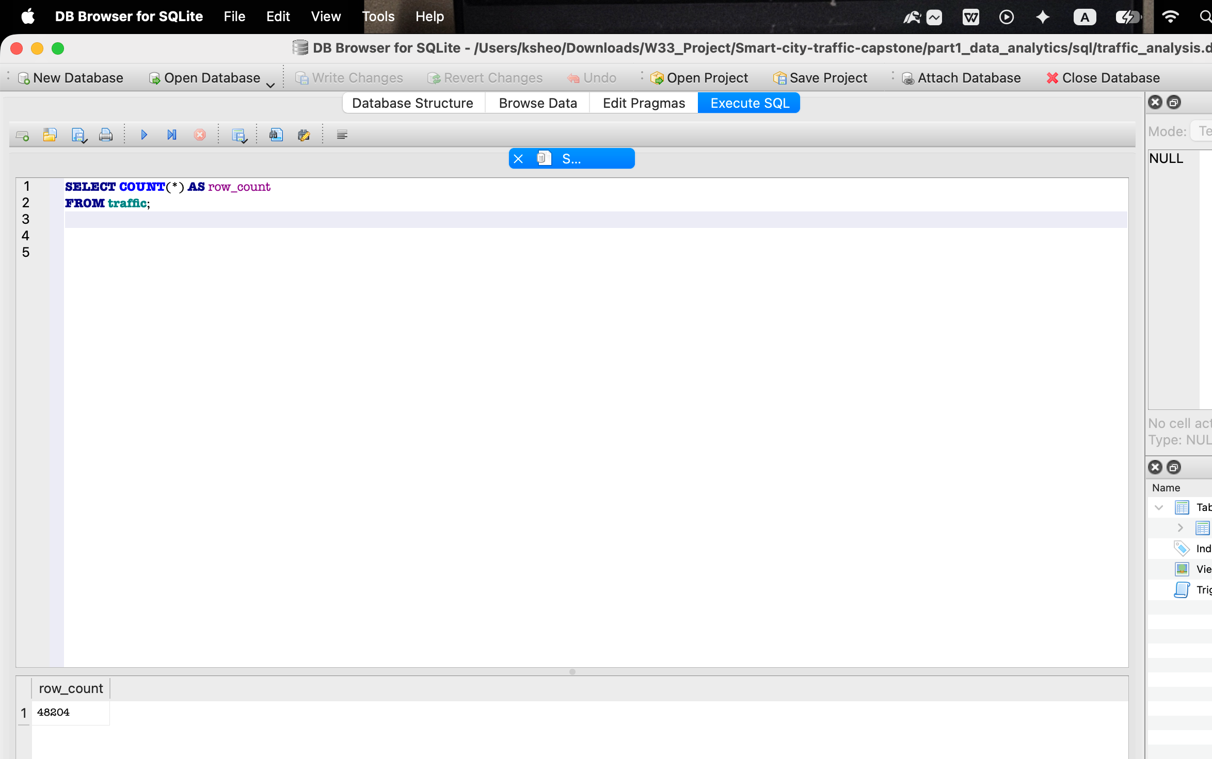

1.2 Analyse annual traffic trends
Compare the total yearly traffic volume for:
- 2012
- 2013
- 2014
- 2015
- 2016
- 2017

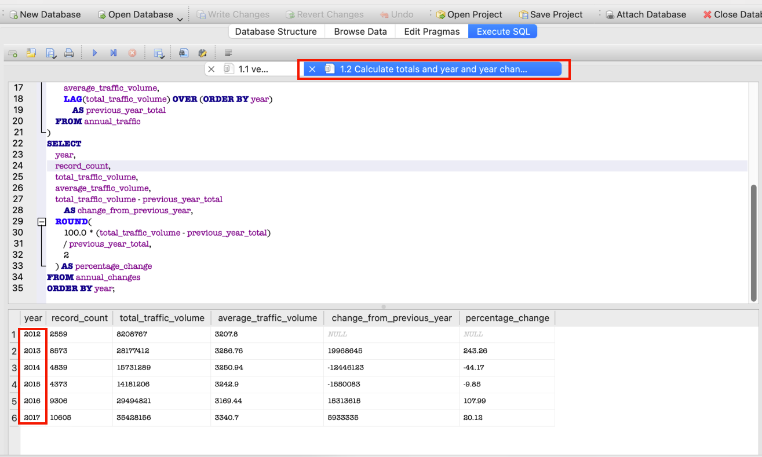
Then:
- Identify years with increases or decreases.
years with increase = 2013, 2016, 2017
Years with decrease = 2014, 2015
- Calculate the change between years where appropriate.
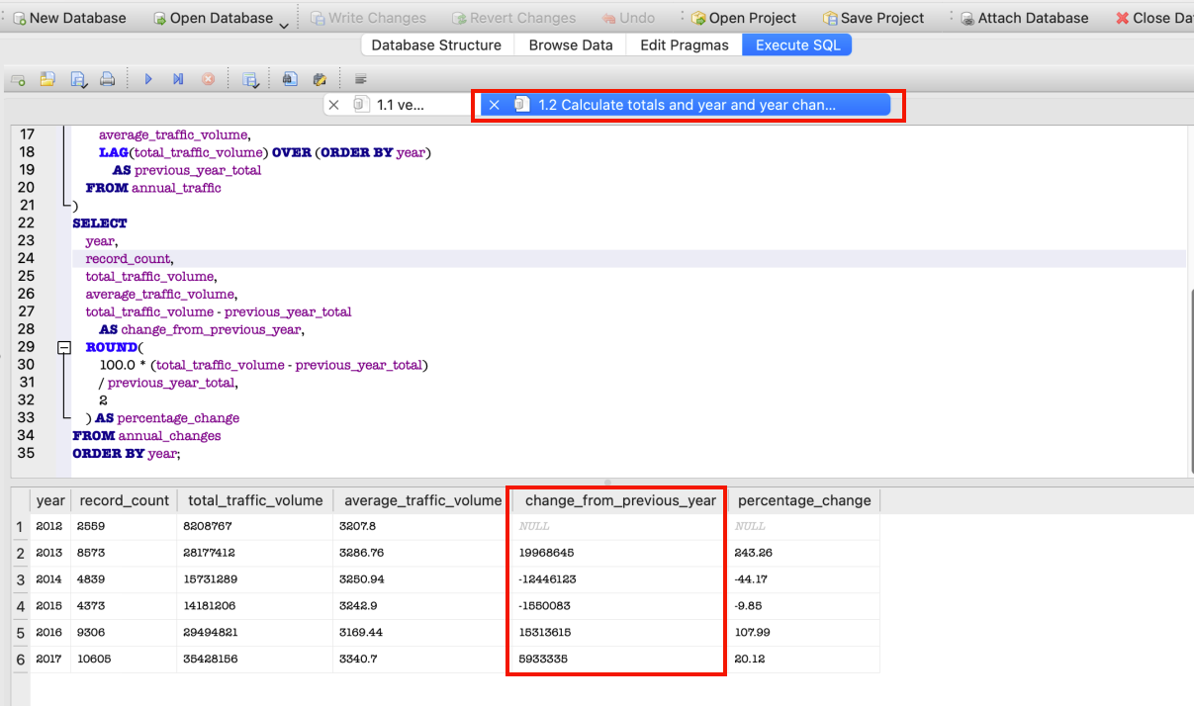
- Explain at least two meaningful observations about traffic volume trends.
Observation 1: Apparent 2013 increase
Total traffic volume increased by approximately 243.26% between 2012 and 2013. However, this should not be interpreted as a genuine tripling of traffic demand because the 2012 dataset contains only records from October to December, while 2013 contains substantially more observations.

Observation 2: Decline during 2014 and 2015
The recorded total decreased by 44.17% in 2014 and by another 9.85% in 2015. These decreases are strongly influenced by incomplete data coverage: the 2014 data ends in August, and the 2015 data begins in June. The relatively stable average traffic volumes—around 3,243 to 3,251 vehicles—suggest that the lower totals mainly reflect fewer recorded hours rather than a major reduction in normal traffic demand.

Observation 3: Increase in 2016 and 2017
Total recorded traffic increased by 107.99% in 2016 and 20.12% in 2017. The 2016 increase mainly reflects the return to near-full-year coverage. The 2017 result is more meaningful because it has almost complete coverage and also recorded a higher average traffic volume of 3,340.70 vehicles, compared with 3,169.44 in 2016.

1.3 Analyse temperature around holidays
Compare temperature patterns for 2015, 2016 and 2017 during:
- New Year's Day
- Labor Day
Identify notable year-on-year changes and discuss whether these changes appear relevant to traffic conditions.

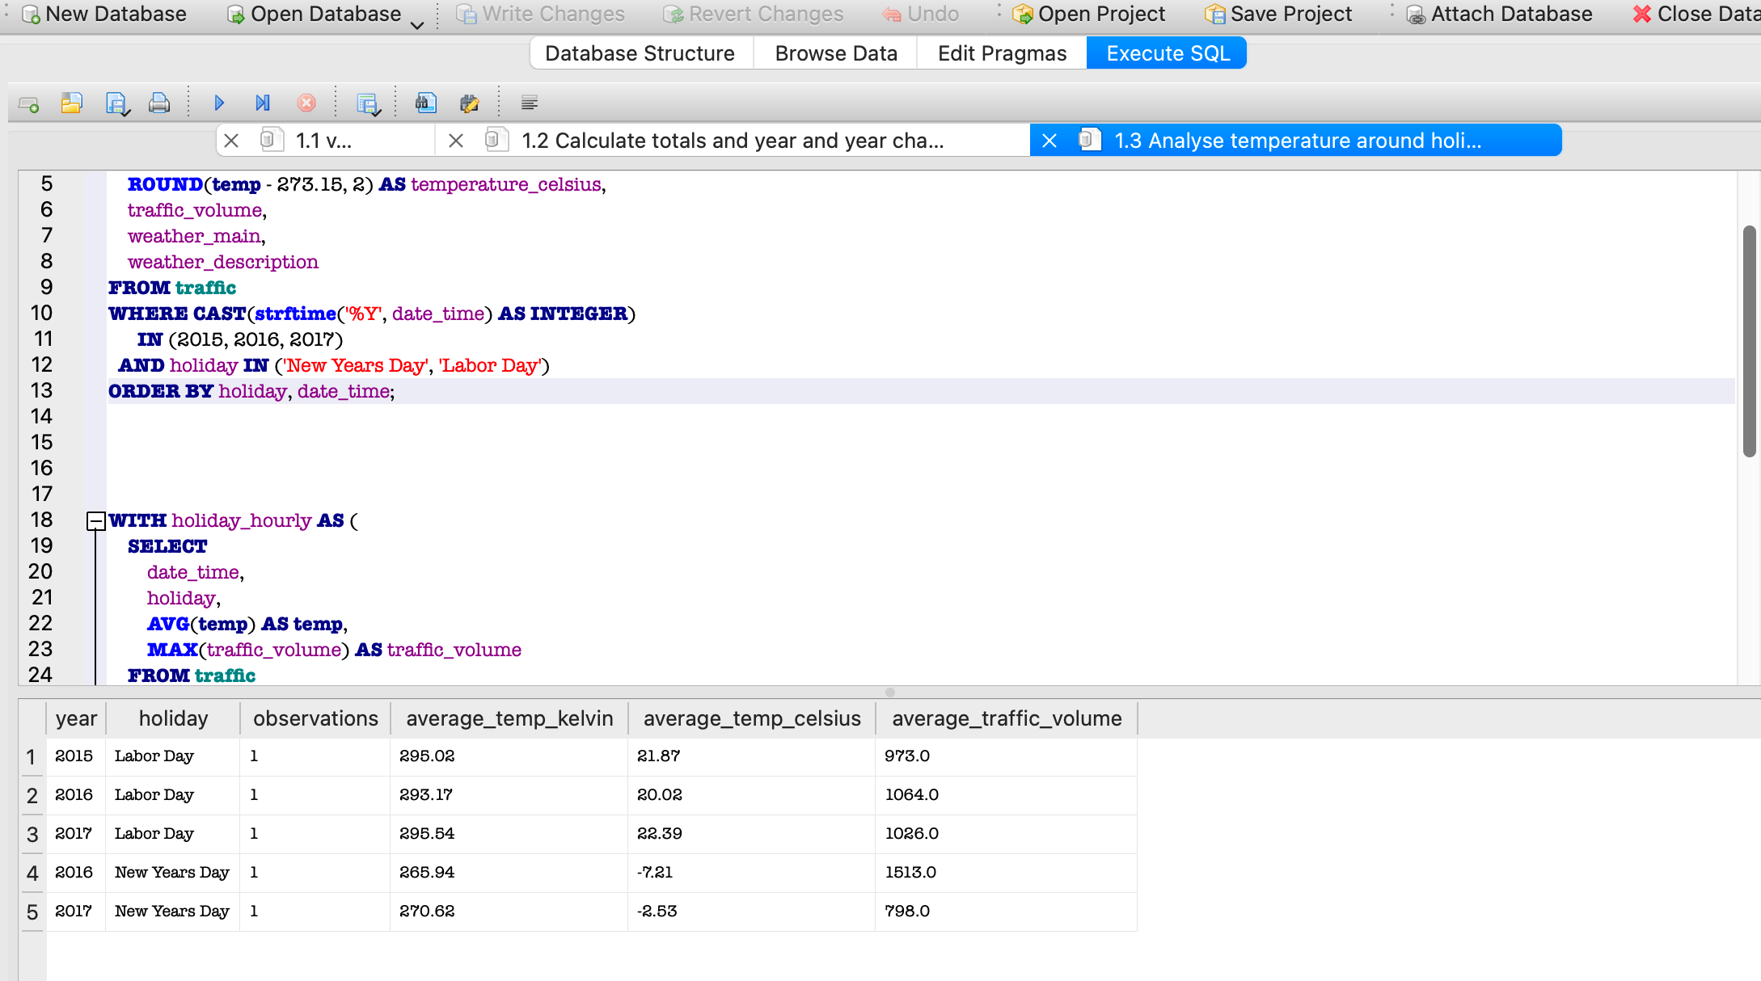
Labor Day
Labor Day temperatures were relatively stable, ranging from 20.02°C to 22.39°C. Traffic volume increased from 973 vehicles in 2015 to 1,064 in 2016, even though the temperature fell by 1.85°C. In 2017, the temperature increased by 2.37°C, while traffic decreased slightly to 1,026 vehicles. This inconsistent movement suggests that the small temperature differences did not have a clear relationship with Labor Day traffic.
New Year’s Day
No New Year’s Day record is available for 2015 because the 2015 dataset begins in June. Between 2016 and 2017, the temperature increased from −7.21°C to −2.53°C, an increase of 4.68°C. However, traffic volume decreased from 1,513 to 798 vehicles, a reduction of approximately 47.26%.
Overall conclusion
The available holiday records do not provide strong evidence that temperature directly determined traffic volume. Labor Day traffic remained reasonably similar despite temperature changes, while New Year’s traffic fell considerably during a warmer year. Calendar effects, holiday observance, weather type and travel behaviour may be more important than temperature alone. The conclusion must also be treated cautiously because each holiday is represented by very few observations and the 2015 New Year record is unavailable.

Task 2: Descriptive Statistics and Correlation
Using the traffic dataset, calculate:
2.1 Traffic volume statistics
- Mean
- Median
- Standard deviation
- Variance
- Range
Interpret what these statistics tell you about traffic volume and its variability.
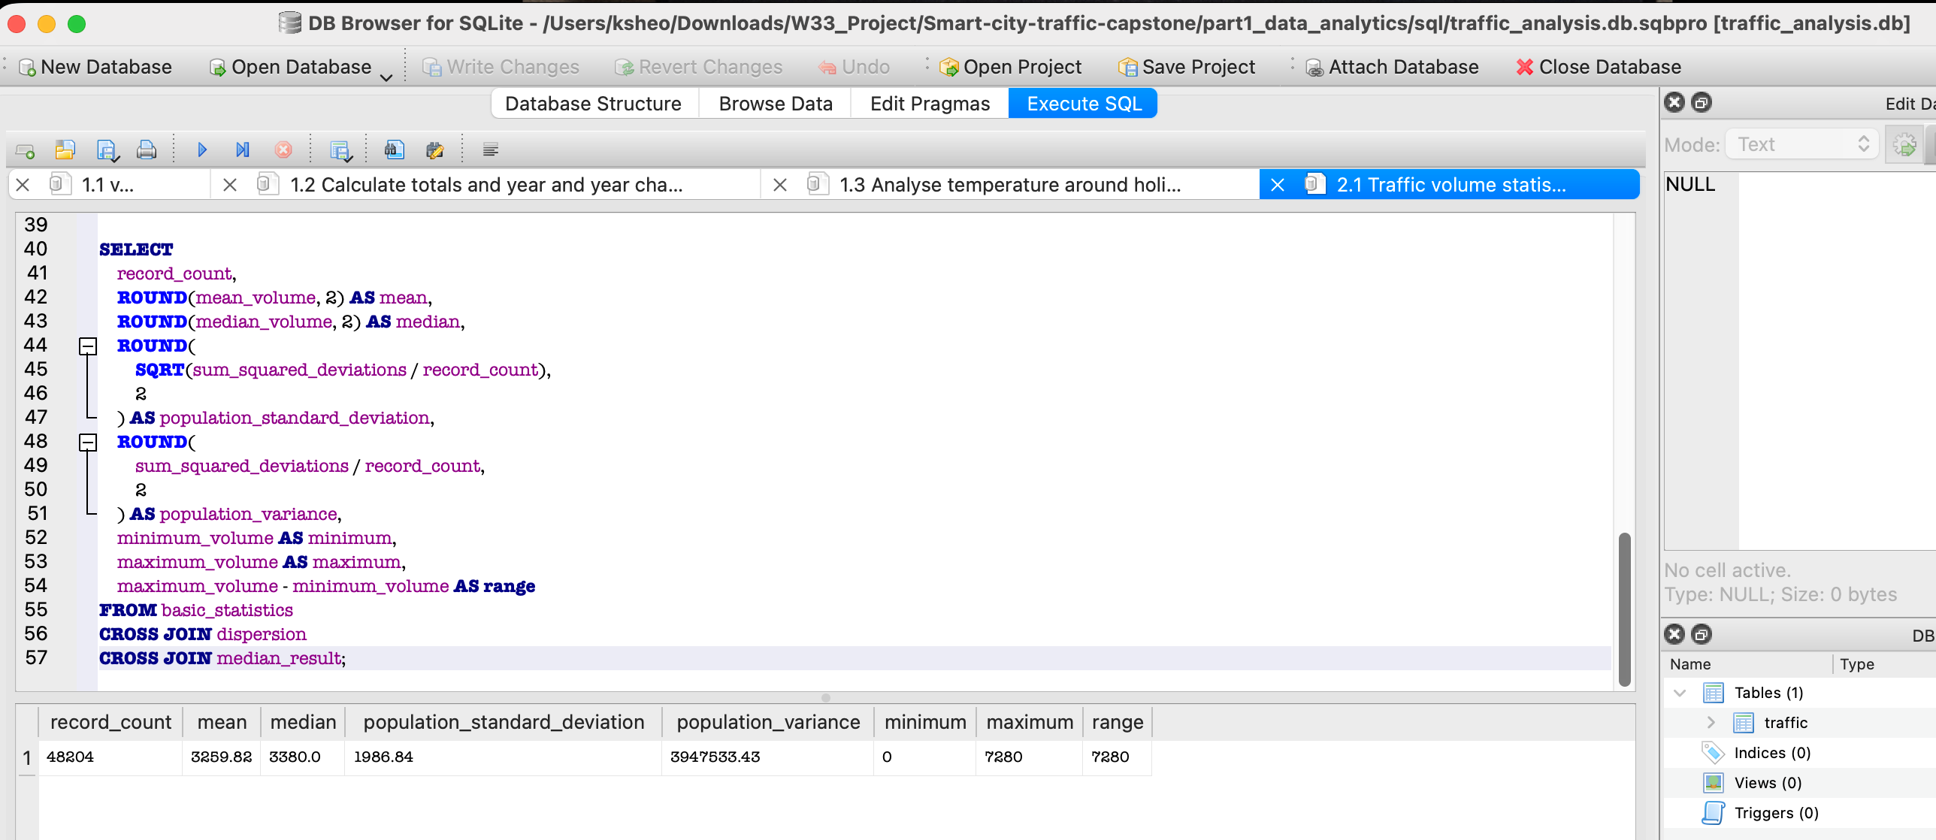
The average traffic volume was 3,259.82 vehicles per hour, while the median was 3,380 vehicles. The population standard deviation was 1,986.84 vehicles, and the population variance was 3,947,533.43 vehicles squared. Traffic volume ranged from zero to 7,280 vehicles. These results demonstrate substantial variability, which is expected because the dataset contains both low-demand overnight periods and high-demand commuting periods. The median was slightly higher than the mean, suggesting that very low traffic observations pulled the mean downward.

2.2 Correlation analysis
Calculate the correlation coefficient between:
- Temperature
- Traffic volume
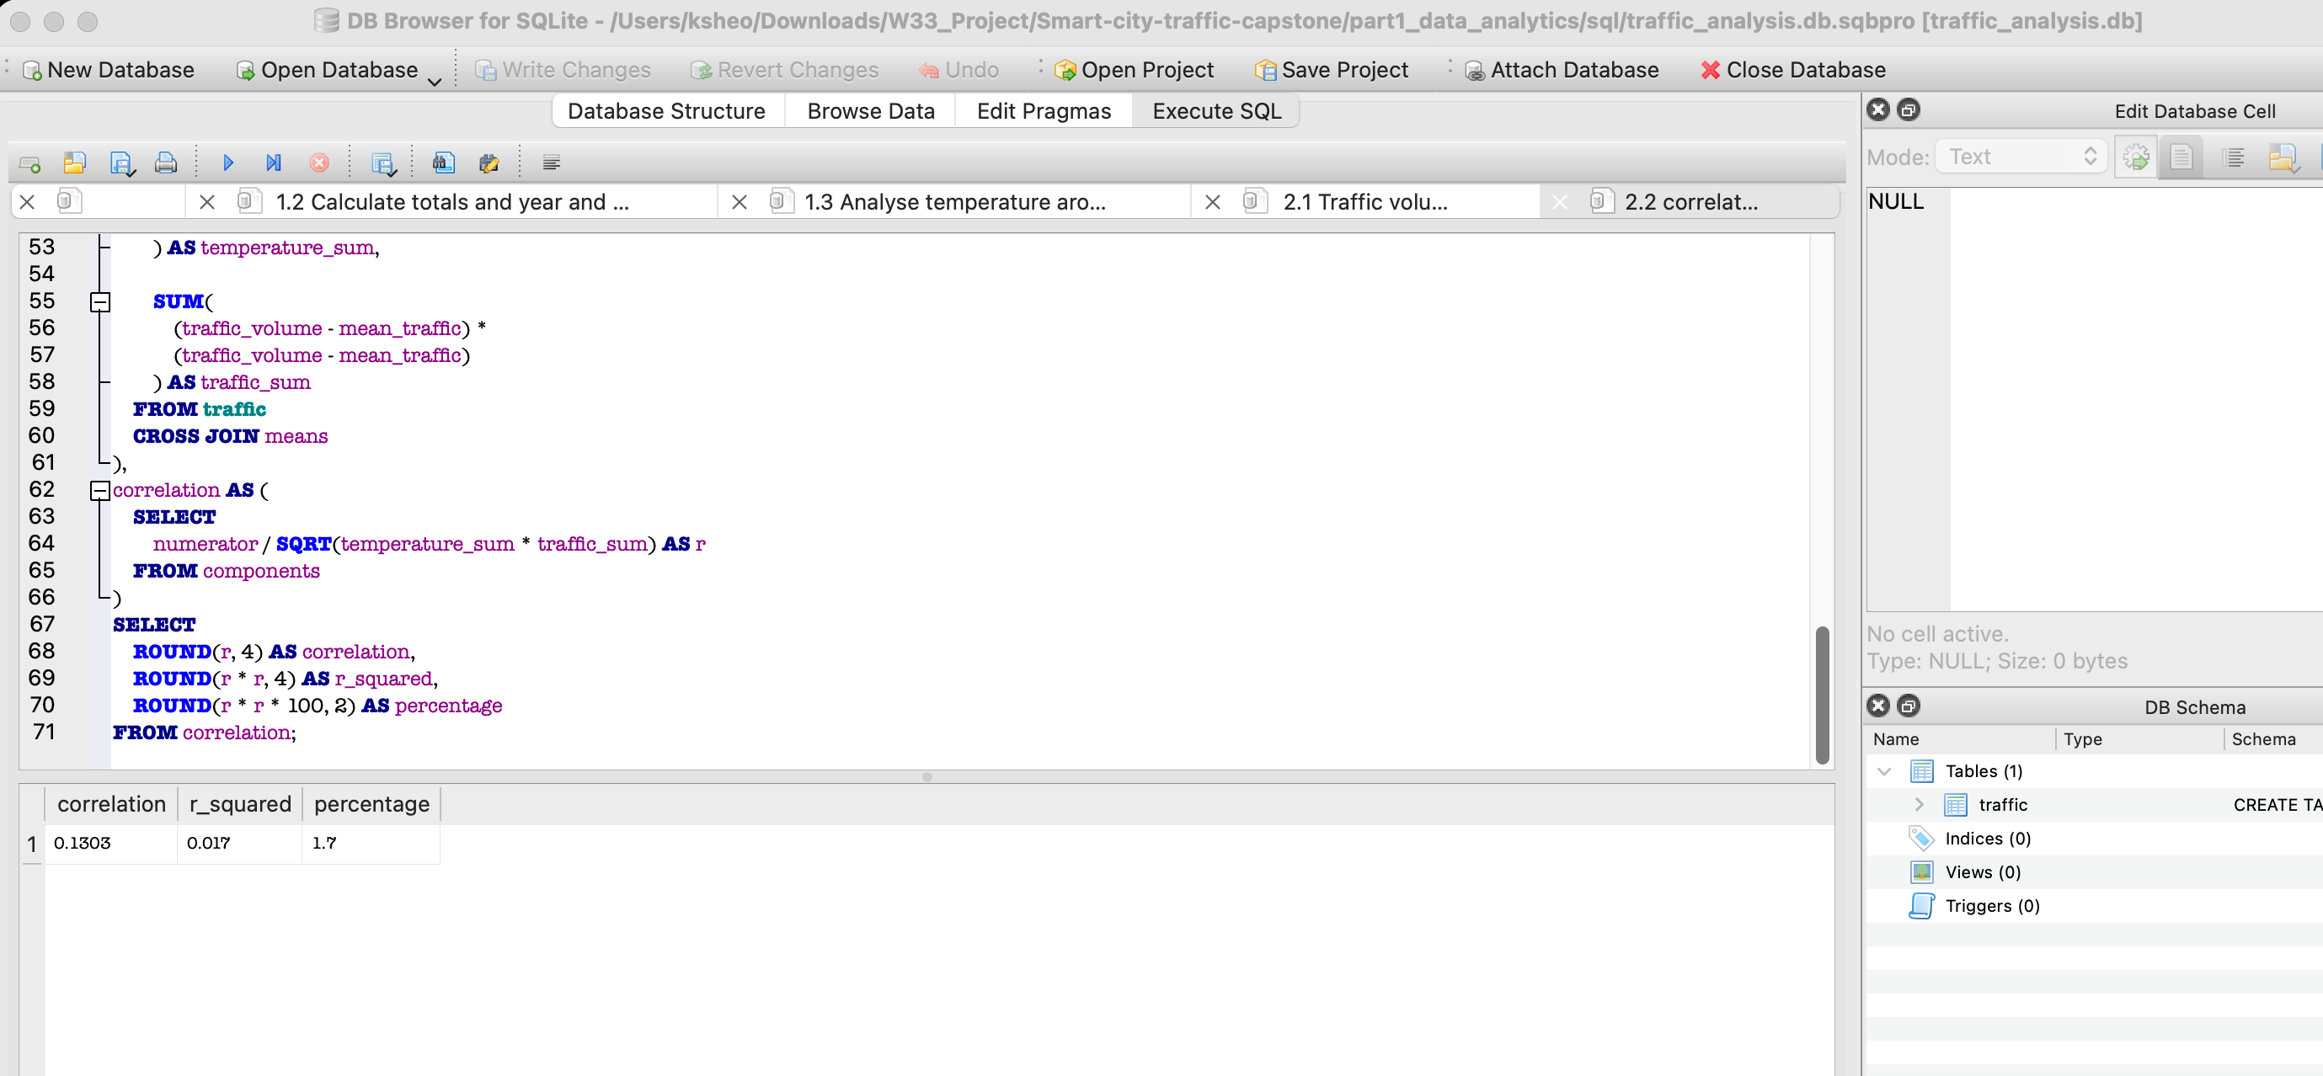
Then:
- Interpret the direction of the relationship.
The correlation coefficient is positive. Therefore, higher temperatures are associated with a slight tendency toward higher traffic volumes.

- Interpret the strength of the relationship.
A correlation of 0.1303 is very close to zero and indicates a very weak positive linear relationship. Temperature alone has little association with traffic volume. The R² value is approximately 0.017, meaning the simple linear relationship accounts for only about 1.70% of the variation in traffic volume.
- Explain why correlation does not necessarily imply causation.
Correlation only shows that two variables move together to some extent. It does not prove that changes in temperature directly cause changes in traffic.
Possible confounding variables include:
- Hour of the day
- Morning and evening commuting periods
- Weekday versus weekend
- Public holidays
- Seasonal travel patterns
- Rain, snow and visibility
- Road conditions
- Special events

Task 3: Probability and Congestion Analysis
Define congestion as: traffic volume > 5,500 vehicles.
Calculate:
3.1 Basic probability
- P(Congestion) =14.73%
- P(Clear Weather) =27.78%
- P(Congestion AND Clear Weather) =3.66%
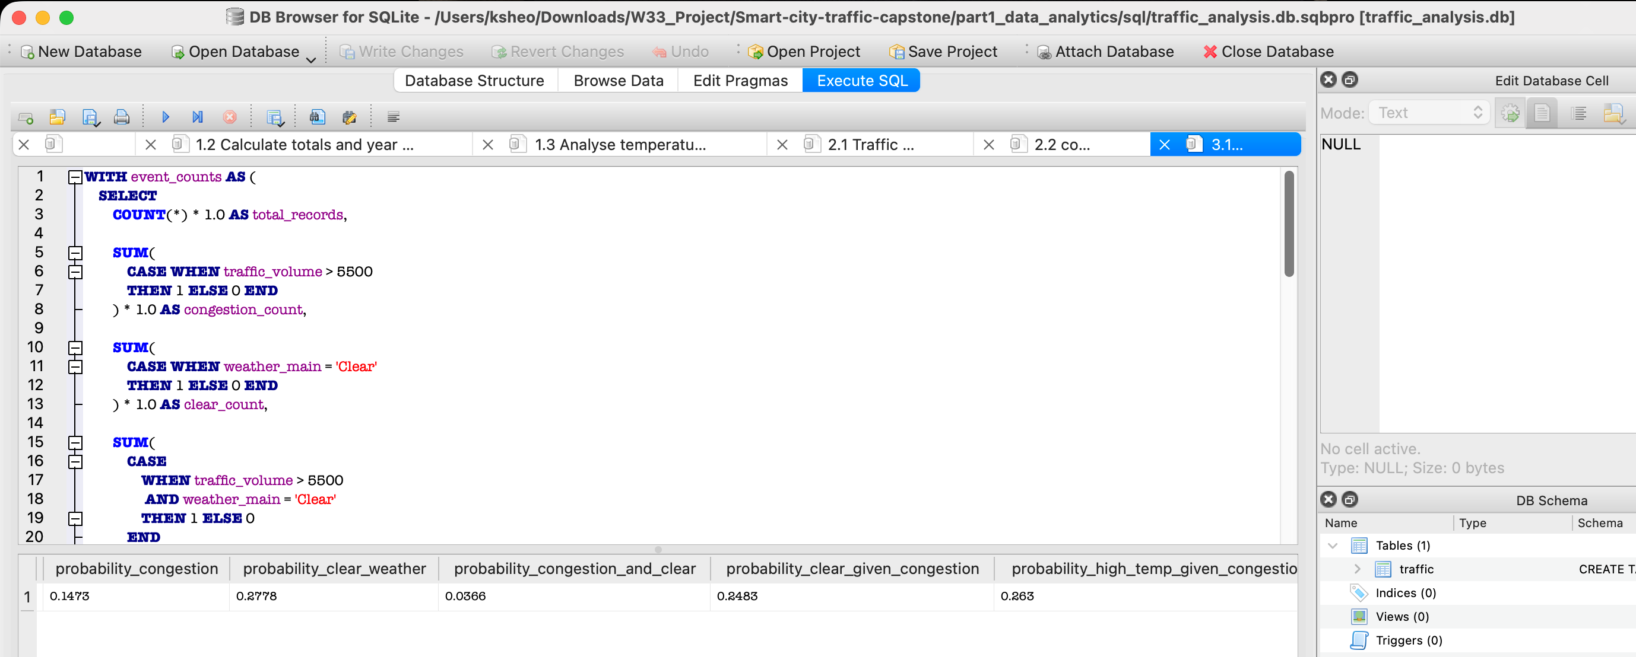
3.2 Conditional probability
Calculate:
- P(Clear Weather | Congestion) =24.83%
- P(High Temperature | Congestion), where high temperature > 292K =26.30%
- Determine whether weather conditions and congestion can be considered independent using P(A ∩ B) = P(A) × P(B)
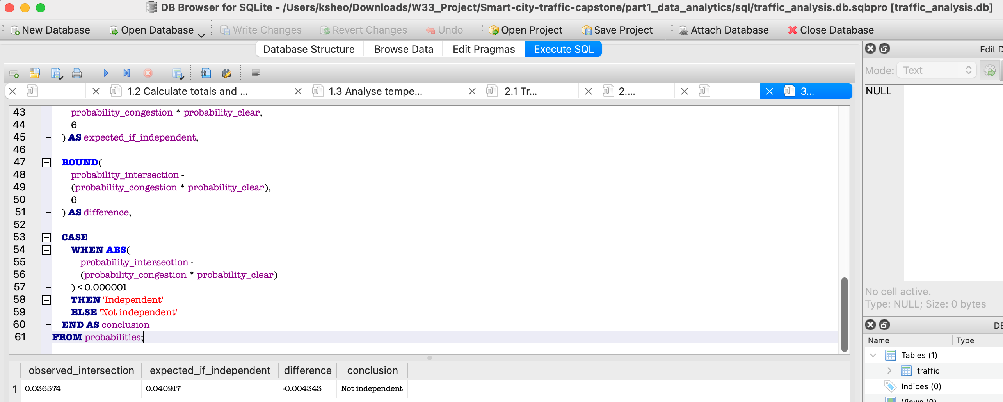
If congestion and clear weather were independent, their expected joint probability would be approximately 4.09%. The observed joint probability was only 3.66%. Because these values are not equal, congestion and clear weather cannot be considered independent according to the specified probability rule.

- Calculate the odds ratio of congestion in clear versus cloudy weather.
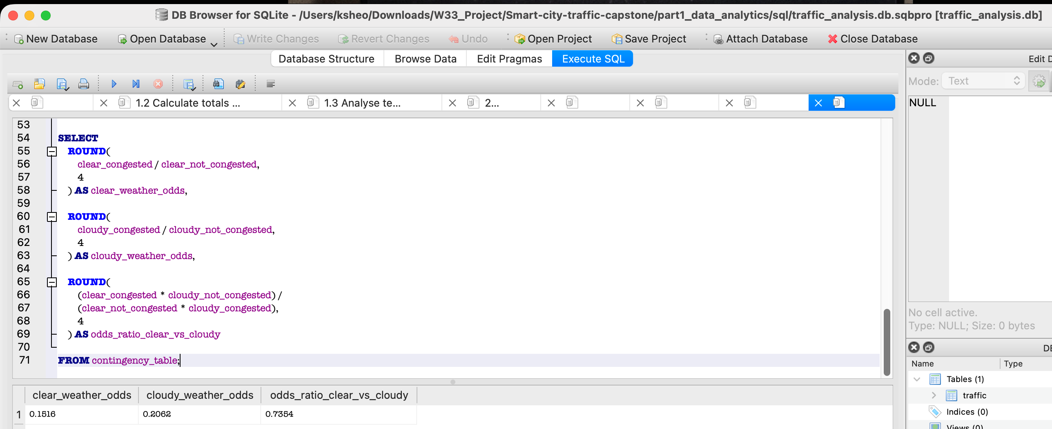
The odds ratio for congestion in clear versus cloudy weather was approximately 0.735. This means the observed odds of congestion during clear weather were about 0.735 times the odds during cloudy weather, or approximately 26.46% lower. Conversely, the odds of congestion during cloudy weather were approximately 1.36 times those during clear weather.
Conclude with a short explanation of what the probability analysis suggests about the relationship between weather and congestion.
Congestion occurred in approximately 14.73% of the dataset, while clear weather occurred in 27.78% of records. The probability of both congestion and clear weather was 3.66%. Clear weather and congestion did not meet the specified independence condition because the observed joint probability differed from the product of their individual probabilities. The odds ratio of 0.735 indicated that congestion odds were approximately 26.46% lower during clear weather than during cloudy weather. However, the analysis does not establish that cloudy weather causes congestion. Factors such as commuting hours, weekdays, seasons and holidays may affect both weather categories and traffic levels.

Task 4: Power BI Traffic Intelligence Dashboard
Import the traffic CSV file into Power BI Desktop and use Power Query Editor to prepare the data.
4.1 Data quality and preparation
Perform the following:
- Determine the number of rows and columns.
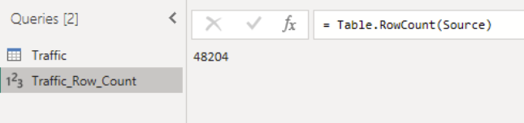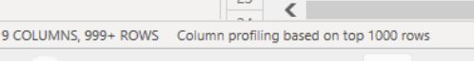
- Identify null/missing values and the columns affected. No null/empty.
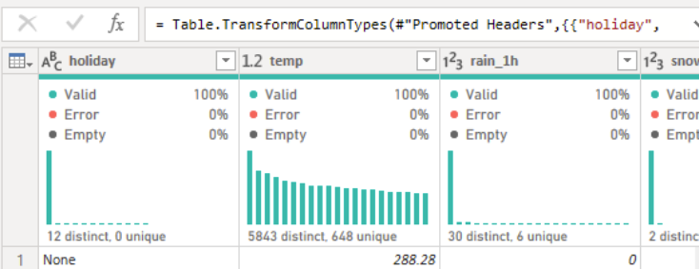

- Check whether the data types are appropriate.
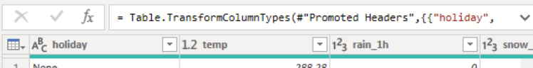
- Extract Hour from DateTime.
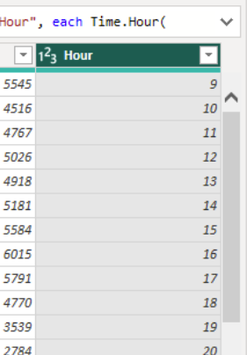
- Create Temperature in Celsius.
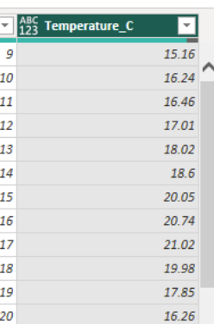
- Create a Traffic Category:
Traffic Volume | Category
< 4,500 | Low
4,500–5,500 | Medium
> 5,500 | High
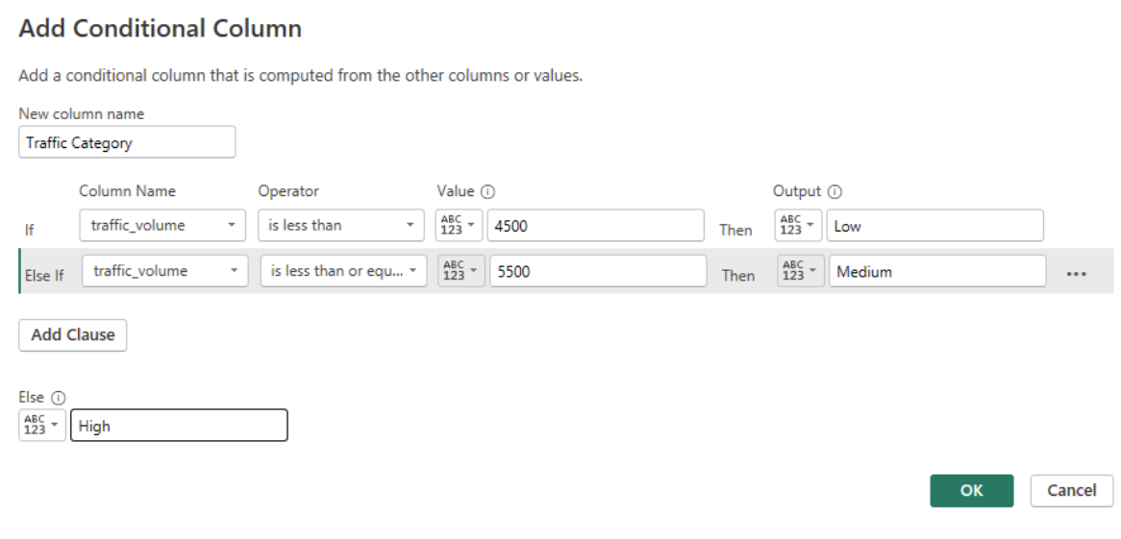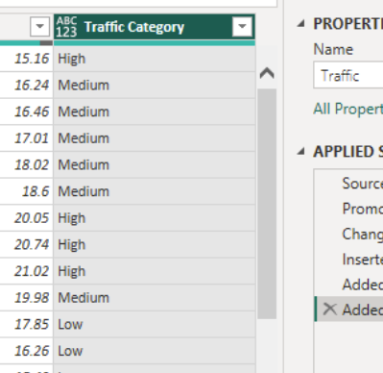

4.2 Dashboard analysis
Create visualisations showing:
A. Daily traffic trends
- Show daily average traffic trends for 2015, 2016 and 2017.
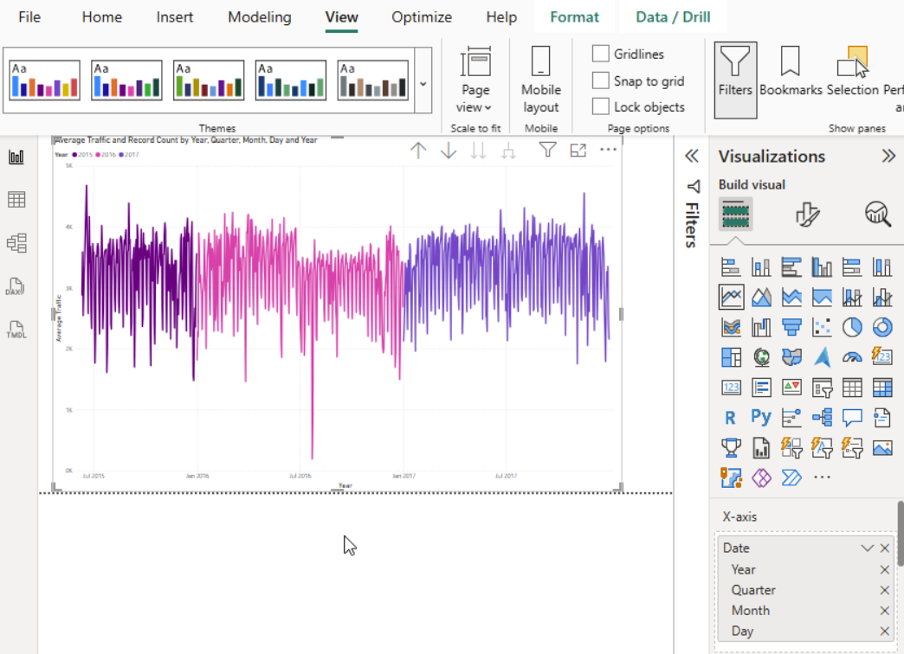
B. Hourly traffic patterns
- Create a column chart showing average traffic by hour for 2017.
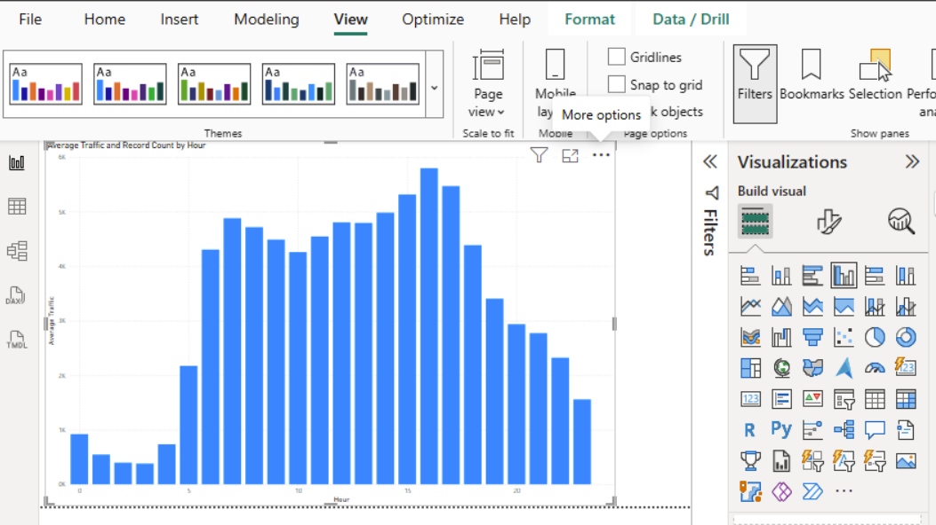
C. Weather impact
Analyse average traffic by weather condition and answer:
- Which weather condition has the highest average traffic?
- Which has the lowest?
- What is the difference between the highest and lowest average traffic?
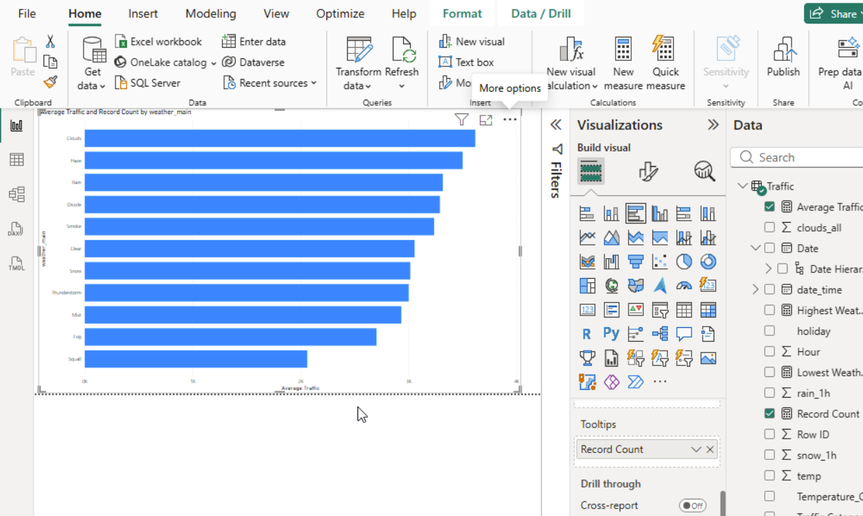
Cloudy conditions recorded the highest average traffic volume of approximately 3,618.45 vehicles, while squall conditions recorded the lowest average of 2,061.75 vehicles. The difference was approximately 1,556.70 vehicles. However, Squall contains only four records, making its average unstable and unsuitable for a strong general conclusion. The chart shows association rather than evidence that weather directly causes changes in traffic.

D. Temperature and traffic
Create a scatter plot of:
- Temperature vs. traffic volume.
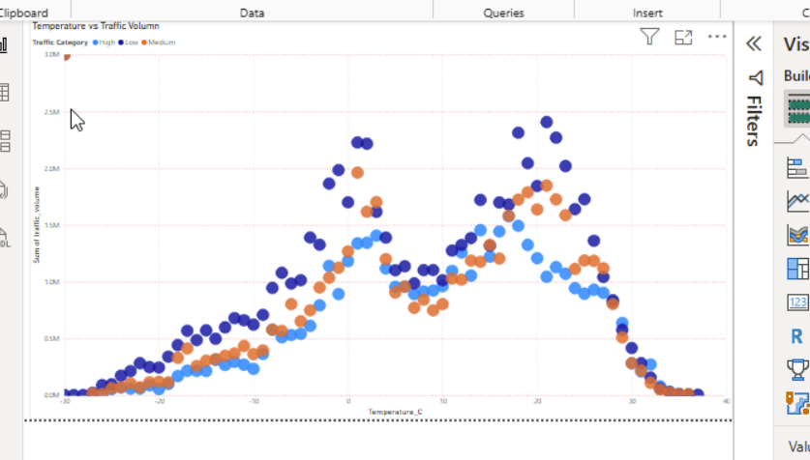
Discuss:
- Whether a visible relationship exists.
The scatter plot shows only a weak positive relationship between temperature and traffic volume. The points remain widely dispersed at nearly every temperature, so temperature alone does not explain traffic demand well. This agrees with the previously calculated correlation coefficient of approximately 0.1303.
- The temperature range associated with higher traffic.
Higher average traffic is most visible between approximately 20°C and 30°C. Records above 30°C also have a high average, but this range contains relatively few observations. High traffic is still present at cold temperatures, indicating that commuting time and day type are likely more influential than temperature alone.
- Any notable outliers.
Ten original records contain temp = 0 K, equivalent to −273.15°C. These are physically impossible sensor readings.
If you used the cleaned Temperature_C formula, these ten records appear as null and are excluded from the scatter plot.
The highest recorded traffic volume is 7,280 vehicles at approximately −2.40°C, showing that extremely high traffic can occur even during cold conditions.
The scatter chart may display a maximum of 10,000 points, so Power BI may sample the dataset; this should be stated as a visual limitation.

4.3 KPI cards and filters
Create KPI cards showing:
- Total hours analysed
- Average traffic volume
- Average temperature
Add slicers for:
- Hour range
- Weather condition
- Traffic category
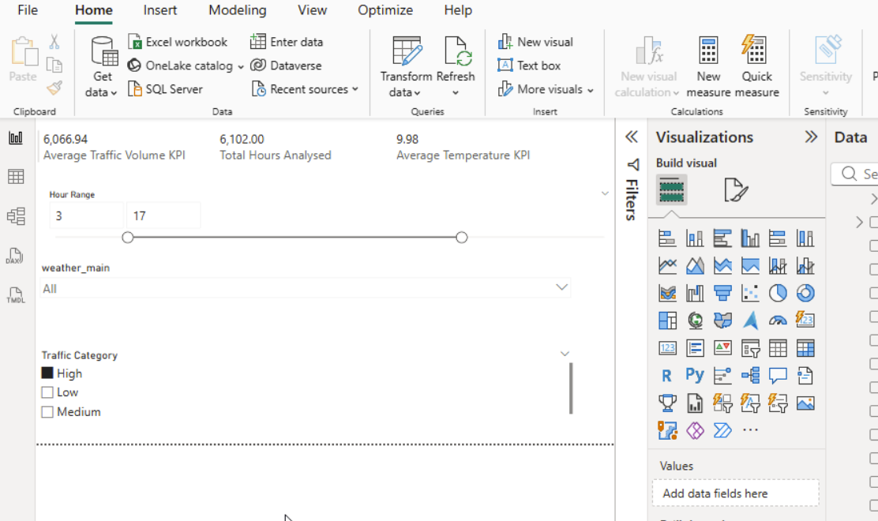
Part 1 Deliverable
Submit:
- SQLite queries/database or SQL file
- Statistical and probability analysis
- Power BI dashboard
- 1–2 page Data Analytics Insights Report summarising the most important findings and their implications for the smart-city mobility team

